Week 6 Practice Task Submission
Publishing, Scheduled Refresh & Report Documentation
Prepared by: Taniya | Retail Sales & Profitability Dashboard (Power BI)
This document records the completion of the three-part practice task: (1) publishing the Power BI report to a workspace, (2) configuring scheduled refresh using an On-premises Data Gateway, and (3) a report definition document describing the calculation logic of each metric for future maintainers.
Task 1: Publish the Power BI Report to a Workspace
The Retail Sales & Profitability Dashboard (built in Power BI Desktop using the Superstore dataset) was published from Power BI Desktop via Home > Publish, and selected into “My Workspace” in Power BI Service (app.powerbi.com). Publishing created two linked items in the workspace: a Report (the visual pages) and a Semantic model (the underlying data model and DAX measures).
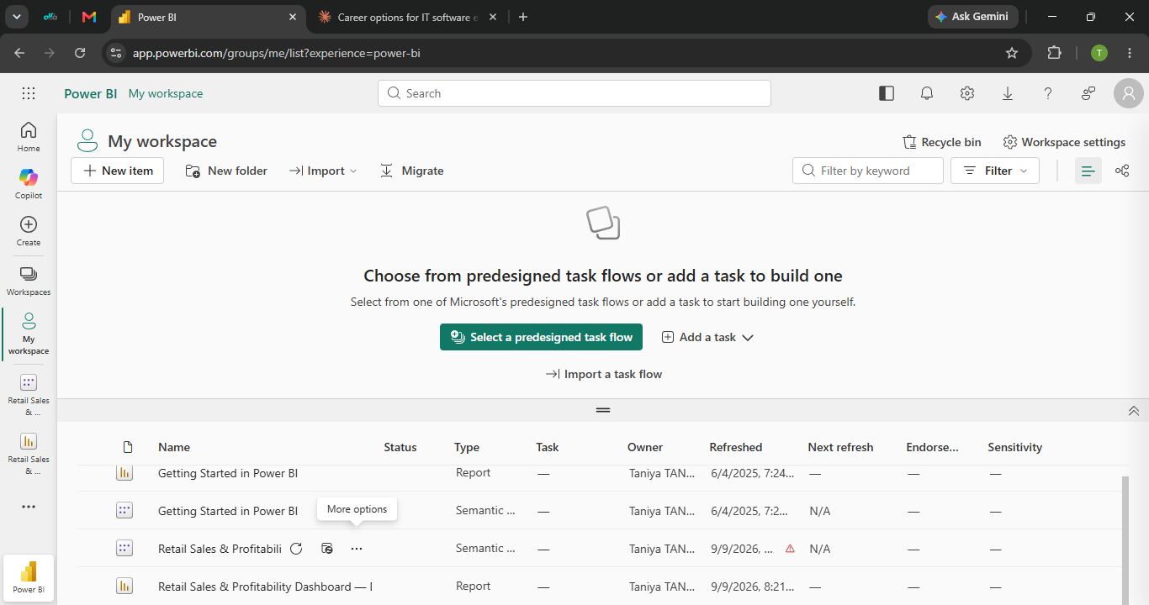
Figure 1: Power BI Service workspace showing the published “Retail Sales & Profitability” Semantic model and Report.
Task 2: Configure Scheduled Refresh (with Data Gateway)
Since the report's data source is a local CSV file rather than a cloud-hosted database, Power BI Service initially could not configure scheduled refresh, returning the message “You don't have any data gateways.” To resolve this and enable a genuinely working scheduled refresh, an On-premises Data Gateway (Personal Mode) was downloaded and installed, then registered to the same Microsoft account used for Power BI Service.
Steps completed:
- Downloaded and installed the On-premises Data Gateway (Personal Mode) from Microsoft.
- Signed in with the Power BI account and registered the gateway.
- Returned to the Semantic model's Settings page in Power BI Service and confirmed the gateway now appeared under Gateway Connection.
- Mapped the data source credentials to the local CSV file path.
- Enabled Scheduled Refresh and set a daily refresh frequency and time.
- Tested the configuration using “Refresh Now” to confirm the connection worked end-to-end.
Note for the reader: a Personal Mode gateway only operates while the host computer is powered on and the user is signed in — it is not a 24/7 managed cloud service, which is an accepted limitation for an individual/student setup as opposed to an organization-managed Standard gateway.
Task 3: Report Definition Document
The following paragraph documents each metric's calculation logic for any future maintainer of this report:
This report analyses a Superstore retail transaction dataset (~10,000 rows) using three core DAX measures. Total Sales is calculated as SUM(Sales), aggregating the raw Sales column across all rows currently in scope based on active filters. Total Orders uses DISTINCTCOUNT(Order ID) rather than a simple row count, because each order can span multiple rows (one per product line item), so counting distinct Order IDs prevents inflating the true number of orders. Profit Margin % is calculated as DIVIDE(Total Profit, Total Sales, 0), where Total Profit is SUM(Profit); the DIVIDE function is used instead of a plain division operator so the measure safely returns 0 rather than an error whenever Total Sales is filtered down to zero. All three measures are filter-context aware and automatically recalculate based on active Region, Category, and Date slicer selections. Future maintainers should note that the Date slicer is bound directly to the Order Date column rather than a separate date dimension table, so if time-intelligence calculations (e.g., Year-over-Year growth) are added later, a proper Date table should be introduced first; scheduled refresh also requires an On-premises Data Gateway to be installed and running, since the underlying data source is a local CSV file rather than a cloud-hosted database.
Appendix: Final Dashboard
The completed and published dashboard, showing KPI cards, category treemap, sales trend, regional map, and interactive slicers:
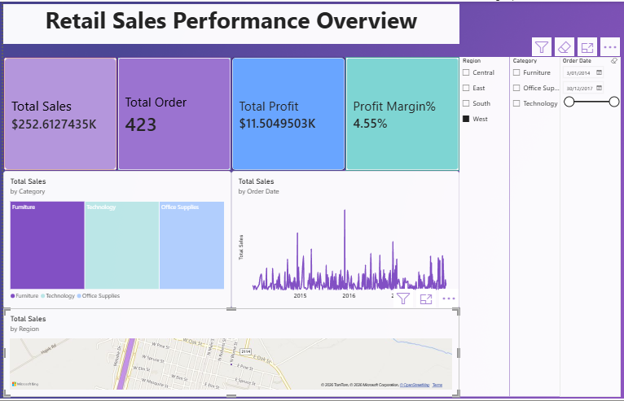
Figure 2: Retail Sales Performance Overview dashboard.
Appendix: DAX Measures Reference
Total Sales = SUM(Superstore[Sales])
Total Orders = DISTINCTCOUNT(Superstore[Order ID])
Profit Margin % = DIVIDE([Total Profit], [Total Sales], 0)

